Server Decom Spreadsheet
The area path and state need to match on the ADO card for proper reporting.
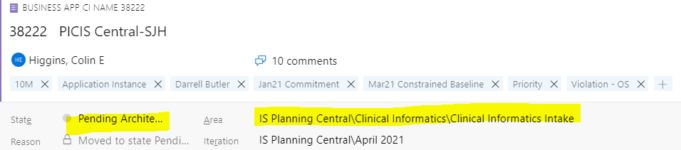

The following are the appropriate combinations of State and Area Path.
Intake
State = Pending Architecture
Area = ___ intake.
** this can be CRCA intake, STE intake, TEO intake, etc.
Lift and Shift
State = Migration in Progress
Area = ____ Lift and Shift
** this can be CRCA Lift and Shift, STE Lift and Shift, etc.
Constrained
State = Constrained
Area = ____ Constrained Apps
** this can be CRCA Constrained Apps, Admin Tech Constrained Apps, etc.
Refactor
State = Refactoring
Area = ______ Refactor
** this can be CRCA Refactor, STE Refactor, etc.
Decom
State = Pending Decom
Area = _____ Decom
** this can be CRCA Decom, Information Security Decom, etc.

Pulling Data to Show Mismatched Area Path
- Go to the ADO board
- Create a query to show all apps
- Save this query as “All Apps”
- Open Excel, pull a new list, connect to the server where the ADO board is located, and select this newly created “All Apps” query
- Select the following columns:
  - Area Path
  - Board Column
  - Iteration Path
  - Assigned To
  - APM Number
  - Work Item Type
  - Title
  - State
- Press Ctrl + A to select all rows of data
- Go to Insert > Pivot Table
- Organize your pivot table’s fields like the image below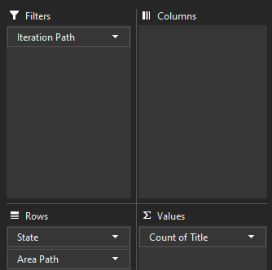
- On the pivot table, select the iteration path filter dropdown
- Click the “select multiple items” check box to choose multiple iterations
- Click on the Rows filter (in the pivot table) and type “Intake”
  - This allows you to view all of the applications that have mismatched states in the intake area path.

